How to install a Webcam

Why would I want to do this?
- To create an instructional video, teach a live lesson, and/or virtually interact with your students

• Connect your webcam to your computer. Many webcams also include a built in microphone and connect to the computer through a USB port. The webcam that you purchase will either come with a separate USB cable or have a USB cable attached to the camera itself. Plug the USB cable into the USB port on your computer. If the computer is a desktop, the USB port will be located in the back and/or front of the system unit.
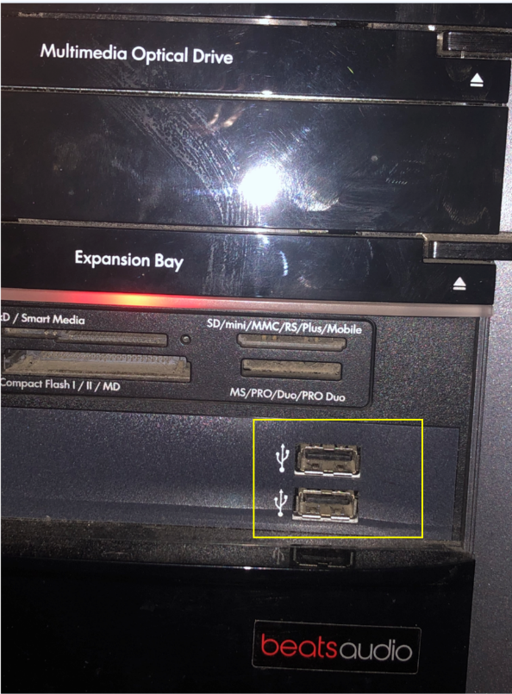
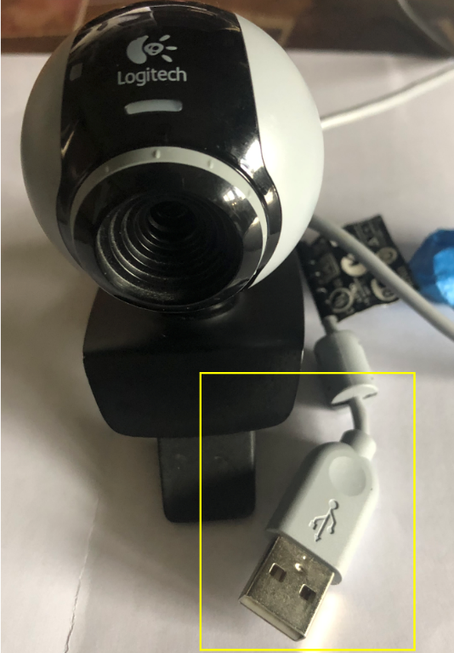

USB Cable USB Port on a desktop

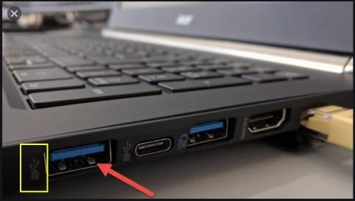

USB Port on a laptop

• Wait for your computer to detect the webcam. Your computer will automatically detect that a new piece of hardware was connected to your USB port. A message will appear in the bottom right corner of your screen that reads, Your devices are ready to use.
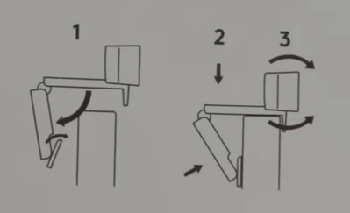

Put your webcam on top of your monitor.

• Follow the manufacturer’s instructions to download the software. This will include testing the webcam and microphone.

